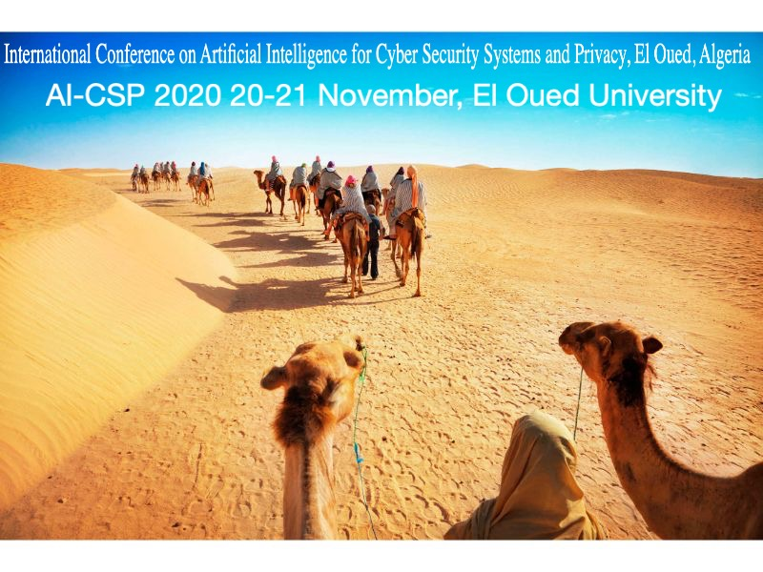

Author Registration Form

Please complete and return this form by October 20th, 2021 with the proof of registration (Copy of Postal Transfer or Credit card)
by Email to ai-csp@univ-eloued.dz

ALL Payment should be done in DZD to:
Account Number (DZD only): 003 00394 101608300047
Bank Name: B.A.D.R Guemar, El Oued, Algeria
Name of Beneficiary: BEKKOUCHE OUAHIB
Motif: Enregistrement AI-CSP

PERSONAL INFORMATION

Title (Prof/Dr/Mr./Ms./Mrs.):
First Name: |  |  |  | Last Name:
Paper Category:
Online Regular Student*
15 000.00 DA 25 000.00 DA [online] 12 000.00 | [regular] 20 000.00

* P.S. All students should present their student cards to benefit 20% of reduction.
Paper EasyChair ID: |  | Paper Title:
Institution:
Address:
Postal Code: | City: |  |  |  | Country:
Phone: | E-mail1: |  |  |  | E-mail2:
Date and City of arrival: (if Regular) |  |  | Date and City of departure: (if Regular)
The registration fees of regular option include proceedings, attendance to all sessions, lunches and coffee breaks on all 2 conference days, 1 social event ticket (Gala Dinner).
Date: Signature:

